Supporting: MSFGN2001 Make measurements and calculations

Assignment for unit
Name |  | Date

Answer the questions below, and show all workings in your calculations.
- You have decided to put in a concrete driveway and rear carport at your house. You have submitted the plan as shown below to the council.
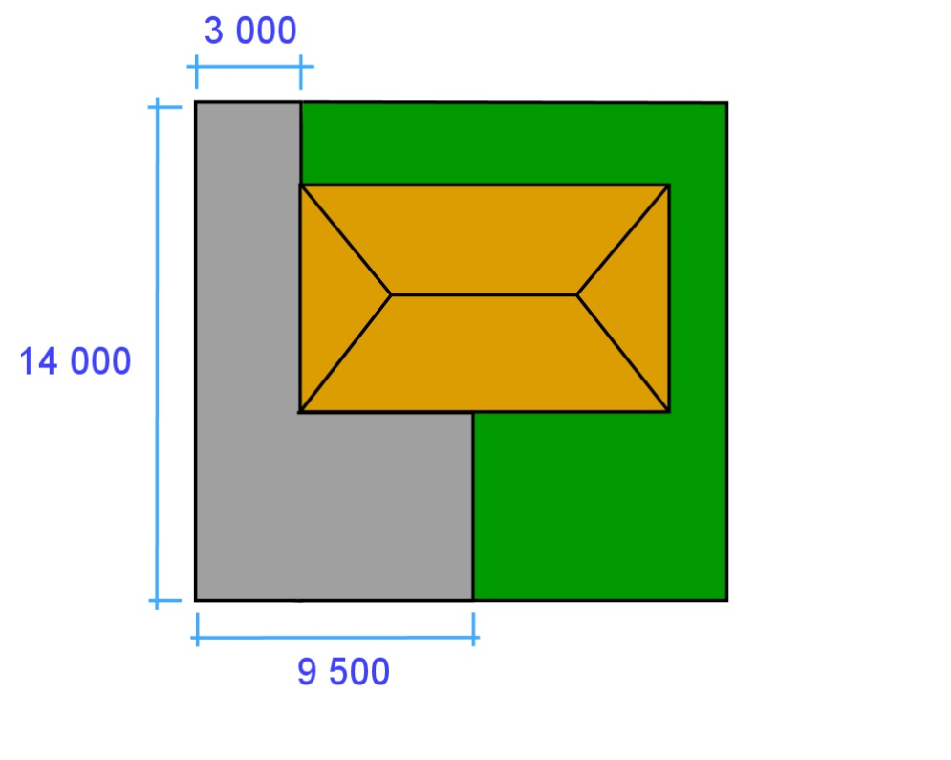

- What is the surface area of concrete in square metres?
- If the slab is 100 mm thick, how many cubic metres of concrete will there be?
- If you allow an extra 10% for minor variations in thickness, how much concrete will you order from the supplier?

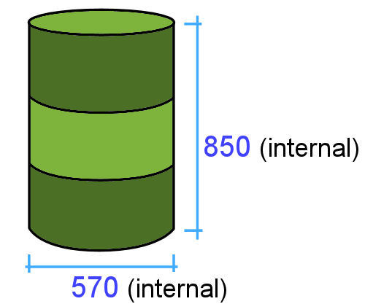
2. A 44 gallon drum has an internal diameter of 570 mm and height of 850 mm.

- What is the drum’s capacity in litres?
(Use the measurements shown to calculate
the volume.)
(b) If you filled the drum with water, what would the total weight be? (Water weighs 1 tonne per m³, and the drum itself weighs 10 kg.)
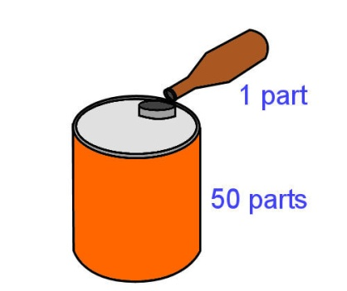
3. Your chainsaw uses high grade two-stroke oil in a 50:1 ratio with petrol.

If the fuel container holds 5 litres of petrol, how much oil will you need to add?

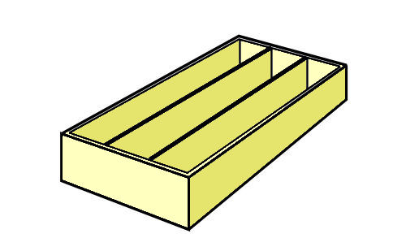
4. You are about to put a plywood back on a set of bookshelves.

(a) How will you check with a tape measure whether all four corners of the bookshelf are square?

5. Choose one measuring instrument that requires calibration, or setting to zero, before it is used.
(a) What is the instrument called?
(b) What does it measure?
(c) What is the process of calibrating the instrument?
(d) What would happen if you took a measurement when the instrument was not calibrated correctly?

